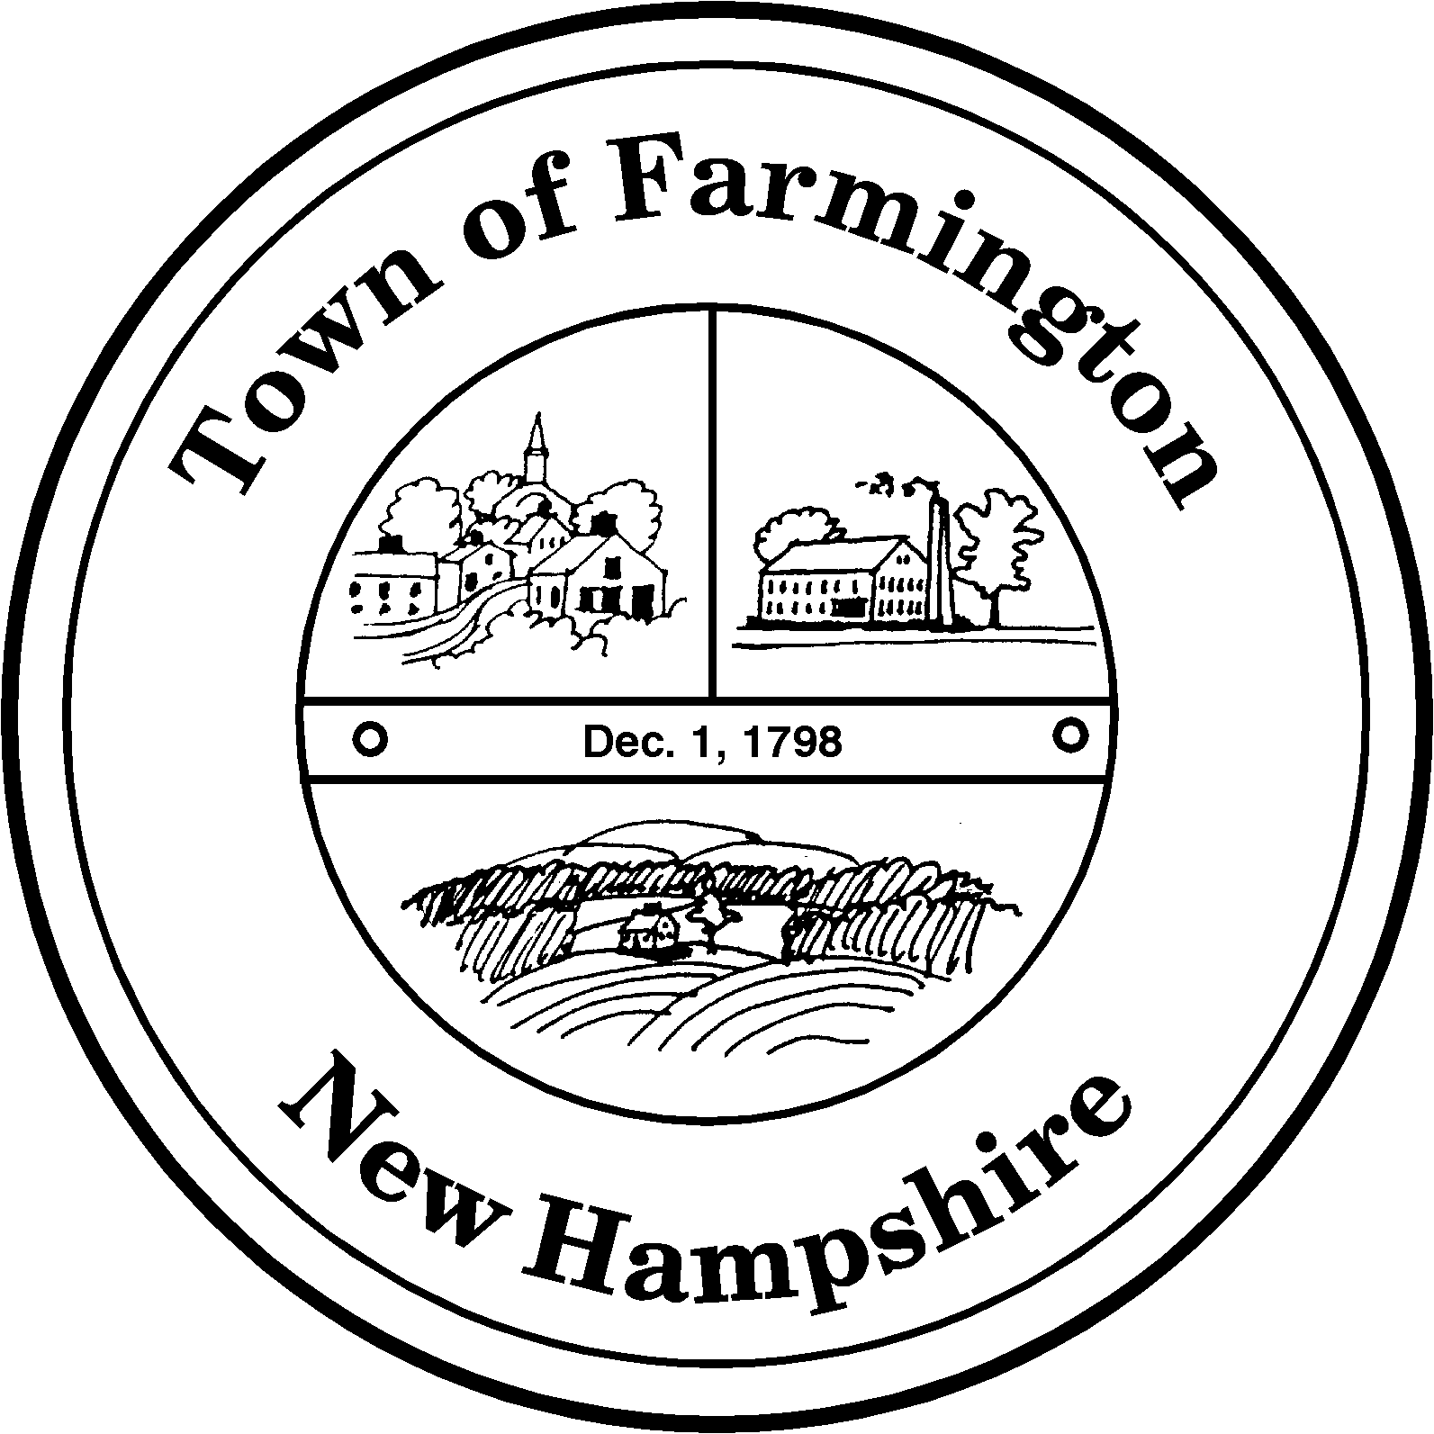
Town of Farmington
Planning and Community Development
356 Main Street
Farmington, NH 03835
Phone: (603) 755-2774
A Bicentennial Community
1798 - 1998

PLANNING BOARD MEETING

Tuesday – February 16, 2016

356 Main Street - Farmington, NH

AGENDA - 6:00 pm

BUSINESS BEFORE THE BOARD:

- Pledge of Allegiance
- Review and approve Meeting Minutes of 02/02/2016
- Continued discussion of active and substantial development and review of Town Counsel comments
- Discussion of 2016 Planning Board Projects
- Any other business to come before the Board

